Project - High Level Design
on
Telecomm Support Triage Agent
  - Course Name: Agentic AI
Institution Name: Medicaps University – Datagami Skill Based Course

Student Name(s) & Enrolment Number(s):
Sr no | Student Name | Enrolment Number
1. | Isha Joshi | EN22CS301438
2. | Harsh Chouhan | EN22CS301387
3. | Goutam Choudhary | EN22CS301370
4. | Goutam Sharma | EN22CS301374
5. | Harshita Chouhan | EN22CS301406

Group Name: Group 03D4
Project Number: AAI-39
Industry Mentor Name:
University Mentor Name:
Academic Year:2026

Table of Contents
Sr No. | Contacts | Page No.
1. | Introduction | 3-4
 | 1.1 Scope of the document
 | 1.2 Intended Audience
 | 1.3 System Overview
2. | System Design | 4-10
 | 2.1 Application Design
 | 2.2 Process Flow
 | 2.3 Information Flow
 | 2.4 Components Design
 | 2.5 Key Design Considerations
 | 2.6 API Catalogue
3. | Data Design | 11-12
 | 3.1 Data Model
 | 3.2 Data Access Mechanism
 | 3.3 Data Retention Policies
 | 3.4 Data Migration
4. | Interfaces | 12
5. | State and Session Management | 12
6. | Caching | 12
7. | Non-Functional Requirements | 12-13
 | 7.1 Security Aspects
 | 7.2 Performance Aspects
8. | References | 13

High Level Design (HLD)
1. Introduction
1.1 Scope of the Document
This document provides a High-Level Design (HLD) for the Telecom Support Triage Agent system. It describes the overall system architecture, modules, data flow, APIs, and design considerations required to build a production-grade AI-powered triage solution. The document focuses on how the system processes incoming telecom support queries, classifies them, extracts relevant information, and generates contextual responses.
1.2 Intended Audience
This document is intended for:
- Software Developers (Frontend & Backend)
- AI/ML Engineers
- System Architects
- DevOps Engineers
- Project Managers
- Stakeholders involved in system design and implementation
1.3 System Overview
The Telecom Support Triage Agent is an AI-driven system that automates the initial handling of telecom customer queries. It leverages Large Language Models (LLMs), Agentic AI frameworks (LangChain/CrewAI), and Natural Language Processing (NLP) techniques.
The system performs:
- Query classification (intent detection)
- Urgency detection
- Named Entity Recognition (NER)
- Context-aware response generation
- Intelligent routing to support teams

The goal is to reduce manual intervention, improve response speed, and enhance customer experience.

2. System Design

2.1 Application Design
The system follows a layered architecture:
- Presentation Layer: User interface (web/chat/email)
- API Layer: Handles communication between frontend and backend
- Business Logic Layer:
  - Triage Agent (orchestrator)
  - Classification Engine
  - NER Module
  - Response Generator
- AI Layer:
  - LLM APIs integrated via LangChain/CrewAI
- Data Layer:
  - Database for storing queries, responses, and logs
The architecture is modular to ensure scalability and maintainability.

2.2 Process Flow
- User submits a query (text input)
- Request is sent to API Gateway
- Triage Agent receives the request
- Classification Engine determines intent and urgency
- NER module extracts key entities (ID, date, issue type)
- LLM processes context and generates response

- Routing module assigns query to appropriate team
- Data is stored in database
- Response is sent back to user or support system

2.3 Information Flow
- Input Data: User query (text/email/chat)
- Processed Data:
  - Intent category
  - Urgency level
  - Extracted entities
- Output Data:
  - Draft response
  - Routing decision
- Storage Data:
  - Query logs
  - AI outputs
  - Metadata
Information flows sequentially across modules but is centrally managed by the Triage Agent.

2.4 Components Design
1. User Interface
- Accepts user input
- Displays responses
2. API Gateway
- Request handling

- Authentication and validation
3. Triage Agent
- Core orchestration engine
- Coordinates all modules
4. Classification Engine
- Detects intent and urgency
- Uses ML/LLM-based classification
5. NER Module
- Extracts structured data from text
6. LLM Layer
- Generates intelligent responses
- Provides contextual understanding
7. Routing Module
- Assigns tickets to relevant teams
8. Database
- Stores structured and unstructured data

2.5 Key Design Considerations
- Scalability: Must handle large volumes of queries
- Latency: Fast response generation (<3 seconds)
- Accuracy: High precision in classification and NER
- Fault Tolerance: Handle API failures gracefully
- Extensibility: Easy to add new features/modules
- Cost Optimization: Efficient LLM API usage

2.6 API Catalogue

1. Submit Query API
- Endpoint: /api/query
- Method: POST
- Input: User query text
- Output: Response + classification

2. Classification API
- Endpoint: /api/classify
- Method: POST
- Output: Intent + urgency level

3. NER API
- Endpoint: /api/ner
- Method: POST
- Output: Extracted entities

4. Response Generation API
- Endpoint: /api/respond
- Method: POST
- Output: Draft response

5. Routing API
- Endpoint: /api/route
- Method: POST
- Output: Assigned department

UML Diagrams :-

Sequence Diagram
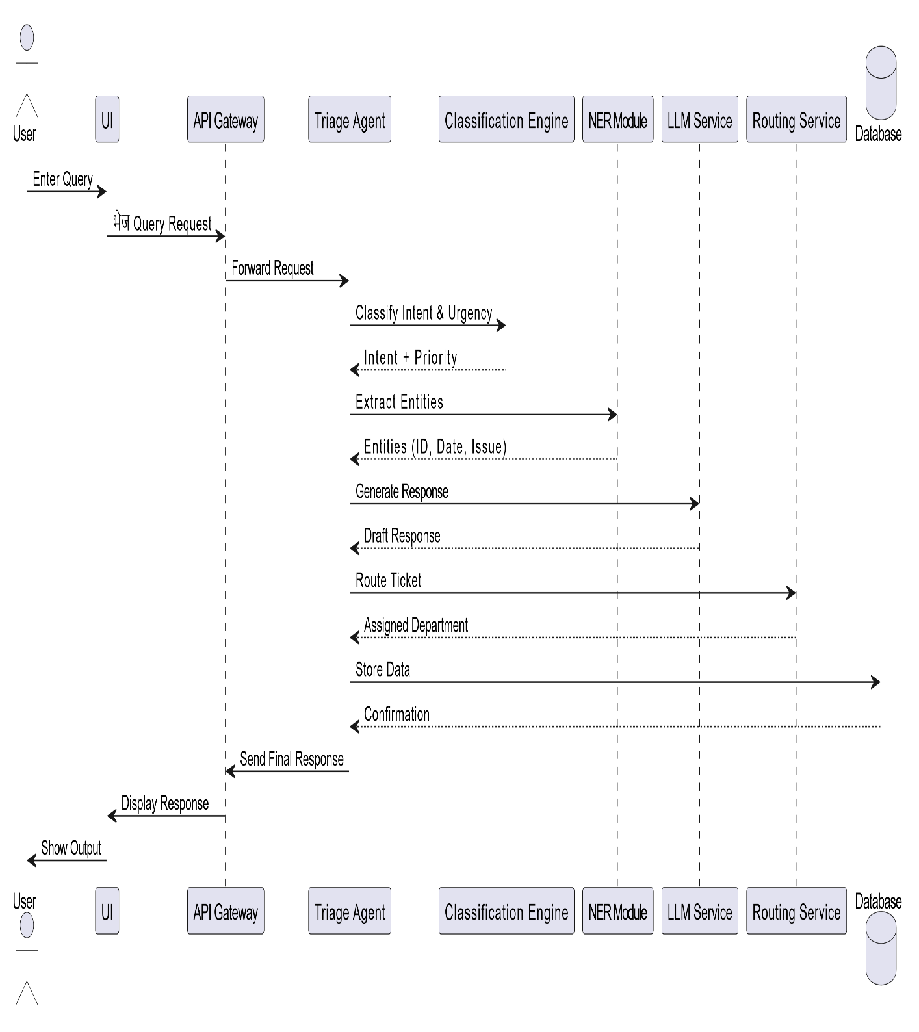

Activity Diagram

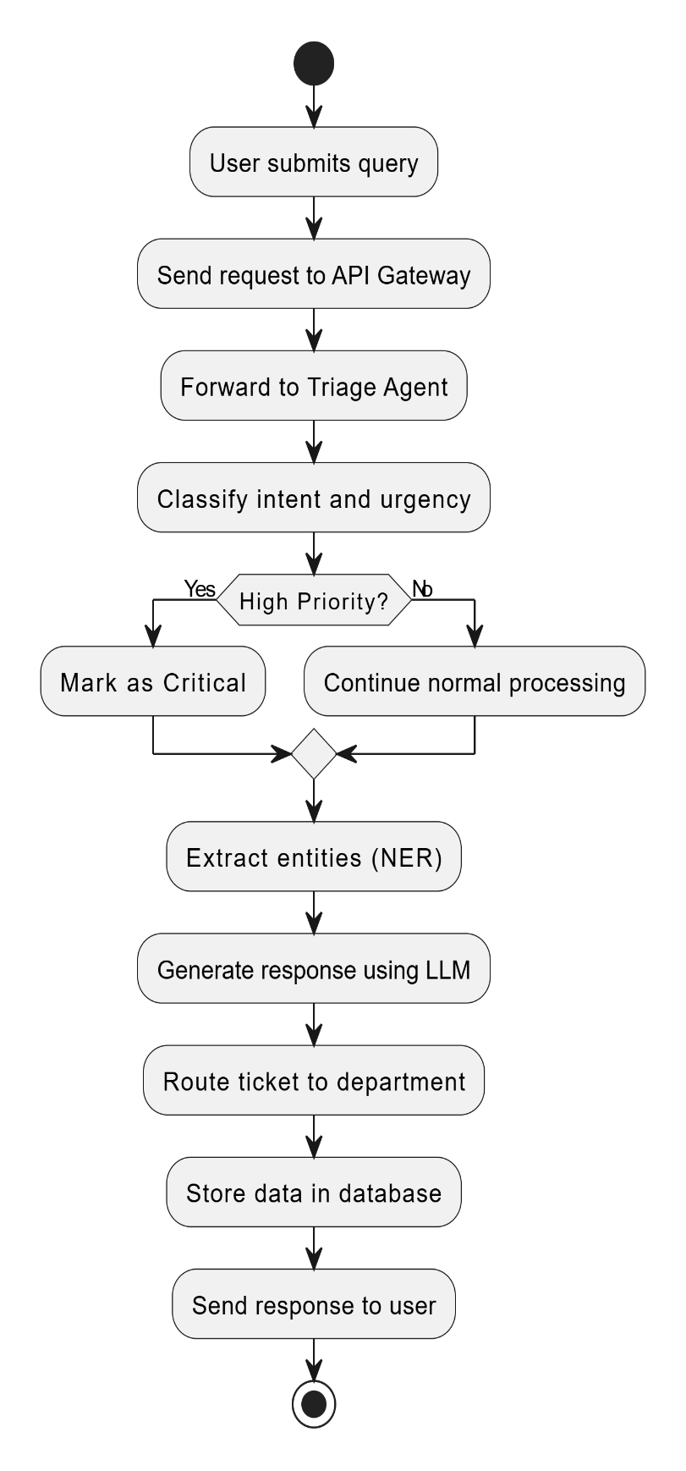

Entity Relationship Diagram

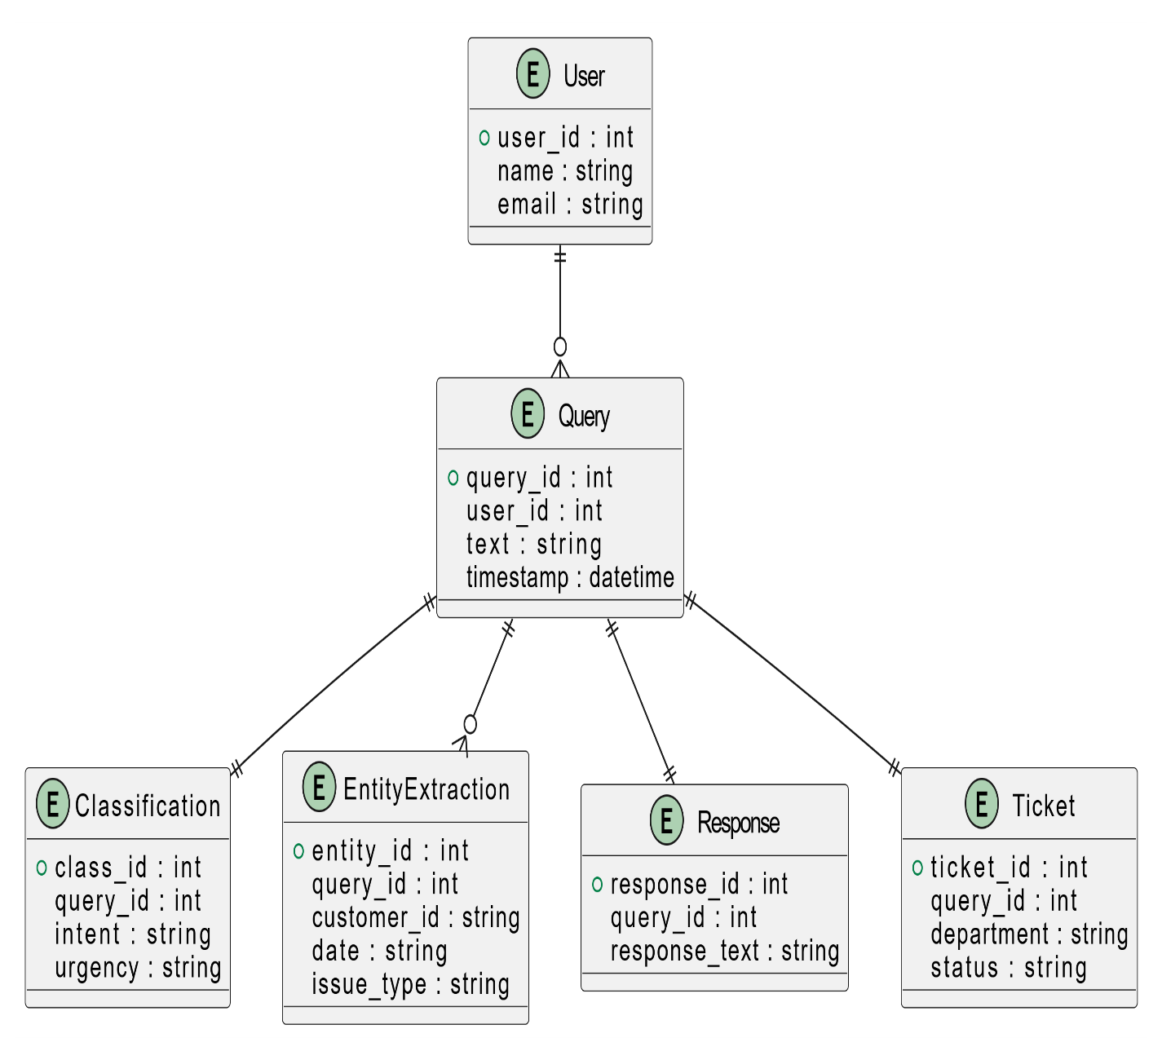

3. Data Design

3.1 Data Model
The system uses structured and semi-structured data:
Entities:
- User Query
- Classification Result
- Extracted Entities
- Response
- Ticket Information
Relationships:
- One query → one classification
- One query → multiple entities
- One query → one response

3.2 Data Access Mechanism
Data Access Mechanism
- REST APIs for data interaction
- ORM (e.g., SQLAlchemy) for database operations
- Secure database connections

3.3 Data Retention Policies
- Store query logs for analysis (30–90 days)
- Archive old data
- Delete sensitive data as per compliance policies

3.4 Data Migration
- Migration scripts for schema updates
- Version-controlled database changes
- Backup before migration

4. Interfaces
- User Interface: Web/chat interface
- External APIs: LLM API integration
- Internal APIs: Microservice communication
- Database Interface: Query execution layer

5. State and Session Management
- Stateless backend design
- Session tracking using tokens (JWT)
- Each request processed independently
- Optional session context for conversation continuity

6. Caching
- Cache frequently used responses
- Use Redis or in-memory caching
- Reduce repeated LLM API calls
- Improve response time

7. Non-Functional Requirements

7.1 Security Aspects
- API authentication (JWT/OAuth)

- Data encryption (HTTPS)
- Secure storage of sensitive data
- Role-based access control

7.2 Performance Aspects
- Response time < 2–3 seconds
- Load handling for concurrent users
- Efficient API and database queries
- Optimized LLM calls

8. References
- LangChain Documentation
- CrewAI Documentation
- LLM API Documentation (OpenAI or equivalent)
- REST API Design Best Practices
- Cloud Deployment Guides (AWS/Azure/GCP)

